
Observatoire Volcanologique
du Piton de la Fournaise



Institut De Physique Du Globe De Paris

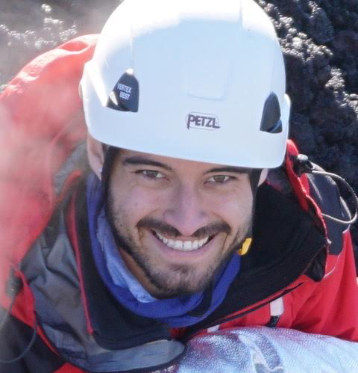
Allan Derrien PhD student at Observatoire Volcanologique du Piton de la Fournaise, La Réunion, Institut de Physique du Globe de Paris

Thursday 10:00 am, 13-September 2018
Aula Riunioni, Area della Ricerca CNR-INGV, Via Ugo La Malfa 153, Palermo

What tremor spectrum tells about the eruptive sites: the 2015-2017 eruption cycles at Piton de la Fournaise
ABSTRACT

Effusion rate is one of the key parameters of volcanic activity. Piton de la Fournaise, with a mean of 1.7 eruptions per year since 1950 and an extended seismic monitoring network, is an optimal laboratory for researching new effusion rate measurement methods. Currently, at Piton de la Fournaise they are estimated from gas or thermal proxies, which are influenced, or blinded, by bad weather conditions. Quantifying activity from tremor alone would enable to overcome this problem. However, tremor recording can also be influenced by eruption dynamics, gaz discharge and local eruptive site effects. In order to constrain how the effects related to eruptive site morphology affect the tremor, our team systematically followed up eruptions by photogrammetry and imagery. We compared 1/ the normalised cross spectral density of horizontal and vertical components of tremor at nearby seismic stations during recent eruptions (2015-2017) with 2/ photogrammetric reconstitutions of the eruptive cone structure and 3/ effusion rates estimated from SO2 fluxes and differential DEMs. We showed that the eruptive cone height, morphology and stability influence significantly the tremor source and can lead to overestimate effusion rates. When the eruptive cone tends to close, this manifests in a preponderance of co-frequencies around or lower than 2Hz. Preponderance of co-frequencies around 3-5 Hz indicates an open eruptive cone, and tremor intensity in this last case has a more direct relation to outflow rate alone. The investigation of this type of law between tremor, eruptive characteristics and effusion rates could improve measurement of key parameters in further research on other volcanoes.

Automated growing of miniature volcanoes in lab: new opportunities for observing long-term trends on basaltic oceanic islands volcanoes
ABSTRACT

Eruptive vents (e.g. cones and craters) at ocean island volcanoes tend to cluster in preferential injection zones, while eruptions in inhabited areas occur less frequently. However, especially the latter may threaten human lives and property. Such distal eruptions often involve horizontal magma transport over long distances. Understanding the processes behind vent repartition and producing vent opening probability maps, constitute a step further towards a better volcanic rick mitigation. We conducted gelatin lab experiments that replicate an ocean island volcano. Both magma and host rock were made of gelatine at 4.5 weight percent. Identical volumes of “magma” were injected 360 times from below an initial crust at intervals of 30 minutes. Each injection was characterised by the emplacement of a new dyke/sill/laccolith/external flow. The magmatic pathways naturally developed in a geometrical manner as opposed to a random pattern. Three sub-vertical “rift zones” at approximate 120˚ angles were accompanied by the formation of deep (near-source) and shallow (near-base) sill complexes. Consistently with previous studies, stress permutations inside the edifice were key factors dictating magmatic pathways and vent locations. Over time, near-surface extensional stresses became mostly radial in the summit zone and tangential on the central cone flanks, explaining the orientation of eruptive fissures. At depth, extensional stresses permuted between vertical and tangential, explaining the cycles of sill/dyke intrusions. Analogue experiments abstaining from regional stress field can replicate the behaviour of intraplate basaltic shield volcanoes remarkably well and therefore open new opportunities for observing long-term trends of volcano edifice growth and internal stress field variations. The effect of parameters such as repose time between injections or injection rate have yet to be explored, promising interesting developments for such models.

